**Legend**

**Staves**

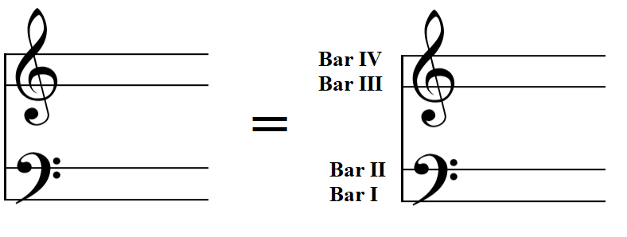

= four different lines indicate four different metal beams in the piano interior

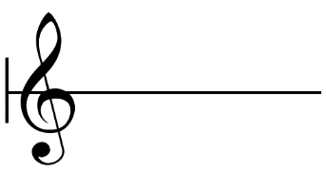

= play/hit on the frame

**Notes & Signs**

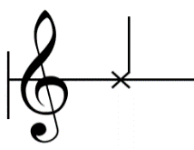

= strike with ERSR mallet/wooden mallet

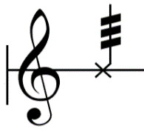

= project ERSR mallet on the frame, forcing it to bounce rapidly

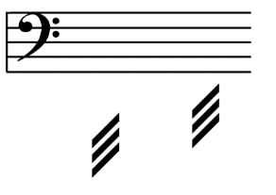

= with strings damped

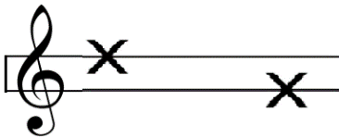

= with knuckle, striking specified beam

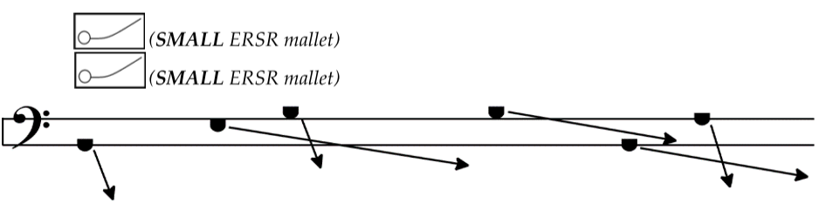

= with ERSR mallets, rubbing specified beam

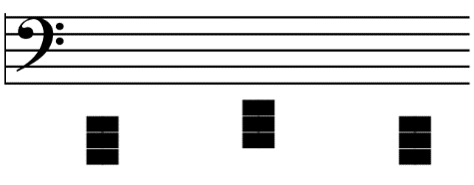

= cluster in piano interior, with palms

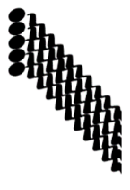

= with fingernails, position on stave represents relative pitch of resulting whooshing sound, change speed of scratching to control this.

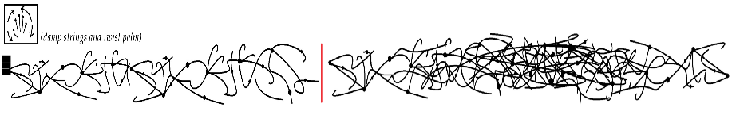

= with palms twisting and damping strings at once

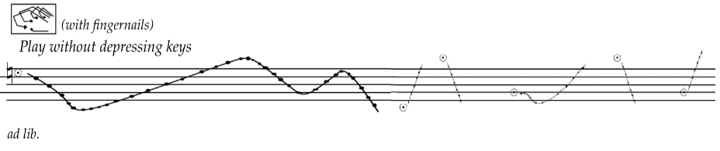

= fingernails glissando without depressing keys

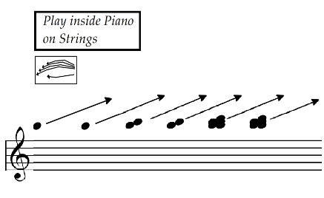

with fingertips, glissando inside the piano = (number of note head indicates number of finger to be used)

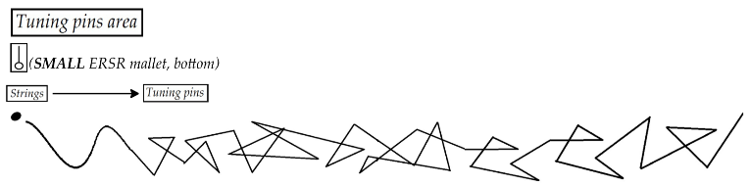

= with the bottom of ERSR mallets, run around in tuning pins area with force

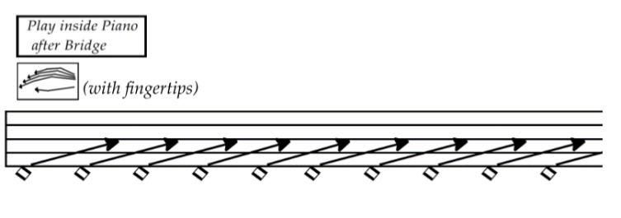

= with fingertips, play behind the bridge

**Other Signs**

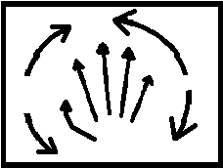

= with palms twisting and damping strings at once

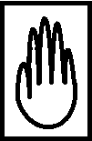

= with palm

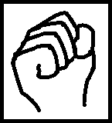

= with knuckles

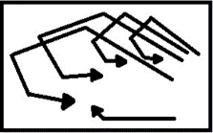

= with fingernails

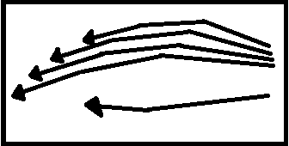

= with fingertips



= ERSR mallet

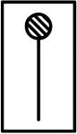

= wooden stick/mallet (or ruler)



= bottom of ERSR mallet

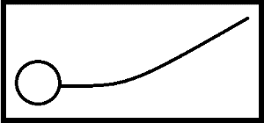

= rub with ERSR mallet